**GetIN Mobile on family planning**

Sharon is a 16 year old and is seven months pregnant. She wants to use family planning but her spouse told her not to even dream of it. Why? Because it will apparently make her smell and infertile. Sharon’s ordeal is the same as that of many young mothers in Kanungu district and Uganda as a whole.

Unfortunate still is that even for the girls that want to use family planning, they cannot access it. In Matanda Health Center III there is a stock out of family planning methods/products as is in many health centers of Kanungu which has led to an increase in unplanned pregnancies. The midwife told us that there is only Depo which was got from some facilities with excess and yet has already expired. Monica\

\\\\ says, ‘*’Mothers come to us crying, blaming us for their unwanted pregnancies because when we couldn’t help them their only alternative was to go to clinics which they say injected them with fake chemicals that do not work*.’’

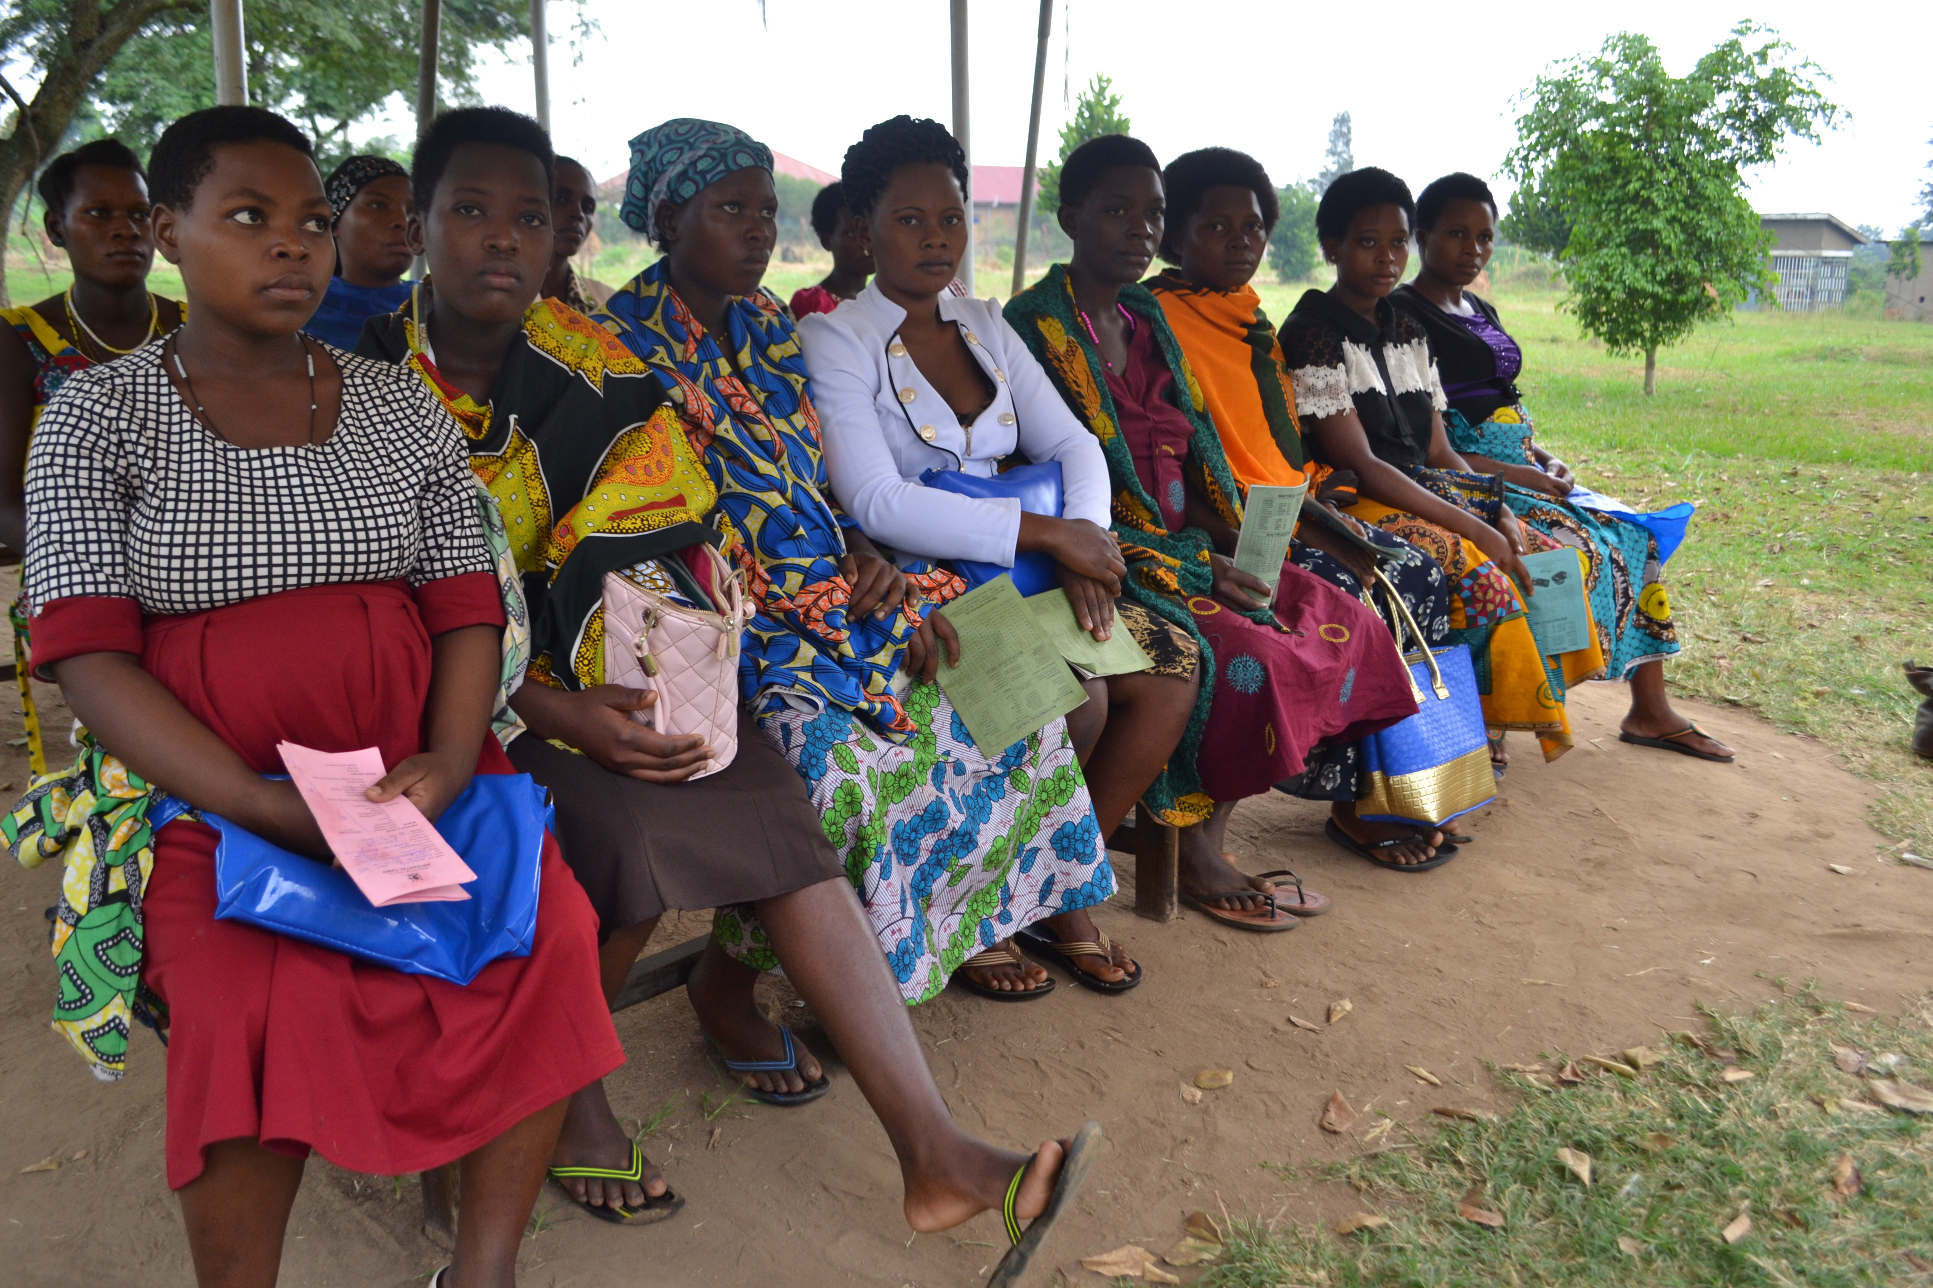**Some of the young pregnant girls (16-21years) waiting for their ANC appointment**

Another midwife from Bundibugyo says she interacted with a young mother, 21 years old and was on her eighth pregnancy. She had high blood pressure and was gravida 7 (number of births) so the midwife got worried and tried to counsel her she got on the defensive and told the midwife off. This girl might have or may still want to use family planning but it is probably not a choice considering many factors. With GetIN Mobile the relationship and communication between the Community Health Extension Workers (CHEWs), midwives and pregnant girls is strengthened and such issues can be dealt with.

Family planning is a strong component of GetIN Mobile because one in four girls have a child by the age of 18 and these very girls will be pregnant again within 24 months of their last pregnancy, what we call repeat pregnancy. This increases the likelihood of the already existing risks like obstetric fistula, still births, maternal mortality among others.

GetIN Mobile also ensures that young mothers are informed on family planning, its methods and advantages after delivery by sending health SMS to these girls till six weeks postpartum and also the app provides means of the health workers calling the girls and vice versa in cases of need.

With GetIN Mobile we shall see more retention of others in ANC, more mothers taking on family planning and safe deliveries at health centers.